There is a saved search that will be scheduled to run each day, and can also be run on demand by a user as needed.

The saved search is:

**L+D | Single Line Orders w/ qty = 1 to Batch Update**

A link to the saved search in Sandbox is here: <https://5086035-sb1.app.netsuite.com/app/common/search/searchresults.nl?searchid=469&saverun=T&whence=>

When this saved search is run it will return a list of sales orders. Based on the results we need a script to update the Batch Pick field on the sales order header for each order returned.

Field on Sales Order Header

Field Configuration

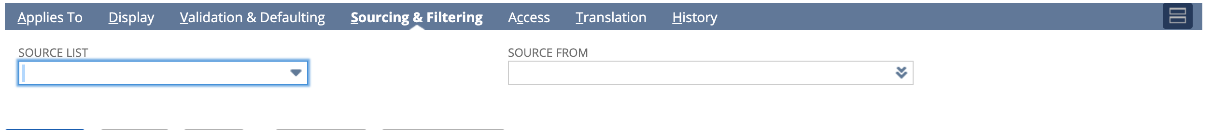

When the saved search runs the script should populate that field with a value equal to todays date.

Example: 070220

*** If possible, it might be worth seeing if you can set the Batch Pick field up as a Date field and populate it with current date based on the results. If that is possible let’s go with that option.

The Batch Pick field will also not be accessible for edit by the end user. It should be set to Display Only.